PSHE! 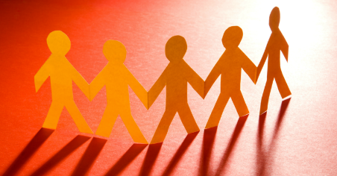
Drama in PSHE!
You wouldn’t guess what we did in PSHE!!! Drama, yes drama! I think everyone loves drama! The drama was about learning how to deal with friendship problems, which actually came in handy. Someone had to be the bully, someone had to be the victim and everyone else had to stop them from arguing and fix their problem. Then we did it the other way round where there was a bully, the bully’s friend and the victim, and we needed to see how the victim felt.
Making paper hands
We made paper hands and colored them in. On each finger it had qualities of a good friend. I put funny, helpful, kind, honest and supportive! I mean, it wasn’t much, but it was fun!!
Refugees
We learnt about refugees, and how hard it was for them in their home countries with all of the war. We did an online story were we got to make choices like a refugee. They had to travel two hundred miles away from their homes, even sometimes without a guardian. When they arrive in a safe country, they don’t always get accepted into camps, or even get a foster home after a long time being there. If they do get accepted, they don’t know the language, so they have to learn how to communicate with people they don’t even know.

