Literacy
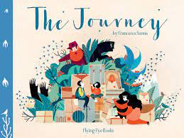
Can you guess what we’ve been doing in literacy this term? We’ve been reading a book about refugees called The Journey. It’s about a family that have to leave their home because of the war and travel far away. It’s an emotion playing picture book by Francesca Sanna.
We have been doing a new literacy method: learning chunks. In our learning chunks, we write ideas for our sentence stacking side where we write our story sentences.
We have also split the story up into parts called ‘Plot points. We rate our characters feelings, positive or negative, for each part of the story. Our plot points all have names:
1- War changes everything, 2- Lost father/Stolen dreams 3- A soothing influence 4- A sad goodbye 5- Journey to the border 6- Night in the forest 7- Guards!! 8- Aboard the boat 9- Flying free
In class, we also did an activity about discarding things. When refugees travel, they have to leave things behind on their way. We picked one thing we would take with us and we made a poem.
The best sentences go up on our classroom wall, where we make a class story as well as our own.

Before The Journey, we did some broches about Sicily. We did different plot points. They were: Overview, Weather, Food, Sights, Activities, Slogan, Data. We also did learning chunks for Sicily.
Another thing we did is river and mountain poems. He is a picture of Ted and Tyler sorting the river poem in the correct order:
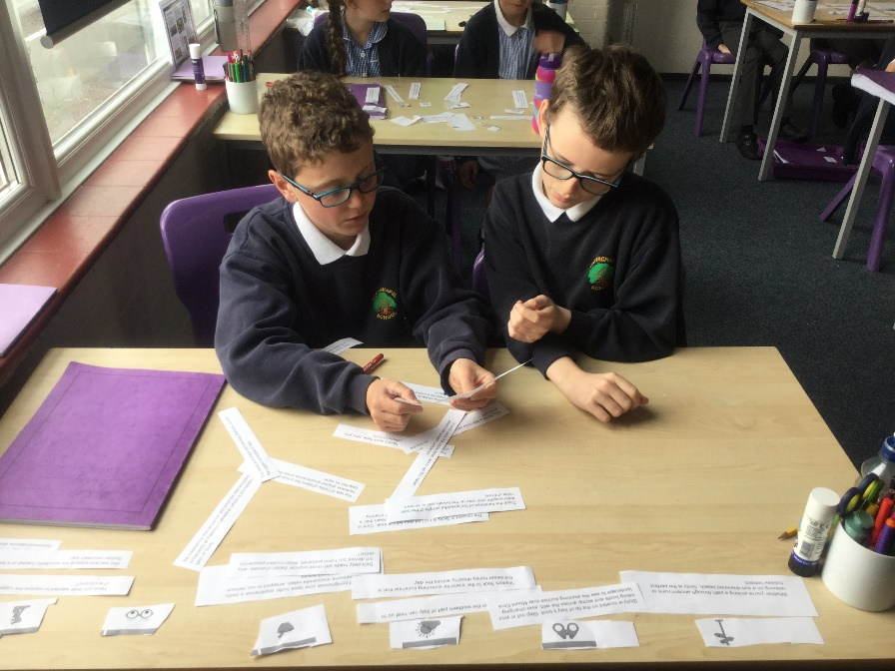
Thanks for reading! Have a good day!

