Astonishing Art.
Sup guys welcome to our new blog we’ll be takin you through the power of art alright so first get your palette and grab the colours blue, green, red, orange, yellow, pink, black, white, brown to get ya started on your art masterpiece aright then.

You can choose whatever type of art your heart desires.
You can do Realism, Impressionism, Pointillism, Fauvism,
Expressionism, Cubism, Abstract, Surrealism or Pop art.
Graciously dip your pointed paintbrush into the colour of your choice and smudge it all over the outside and you’ve got yourself a border then get the colour blue or pink and carefully spread it in the form of a superb square and you’re gradually getting your amazing piece of artwork complete.
Ok alright you’re doing good now get red and yellow and make the shape of a diamond and cover half of it red half of it yellow it doesn’t matter what side you put the colours on.
The last step of your outstanding piece of art is to form a dodecagon at the top right corner and oh yeah, forgot to mention the art club we do on Fridays is open to Dragonfly Class exclusive. In art club we have done some amazing art such as dandelions and creating art on any sort of ball we wanted and created a theme around it now back to the blog.
Ok your art should look like this:
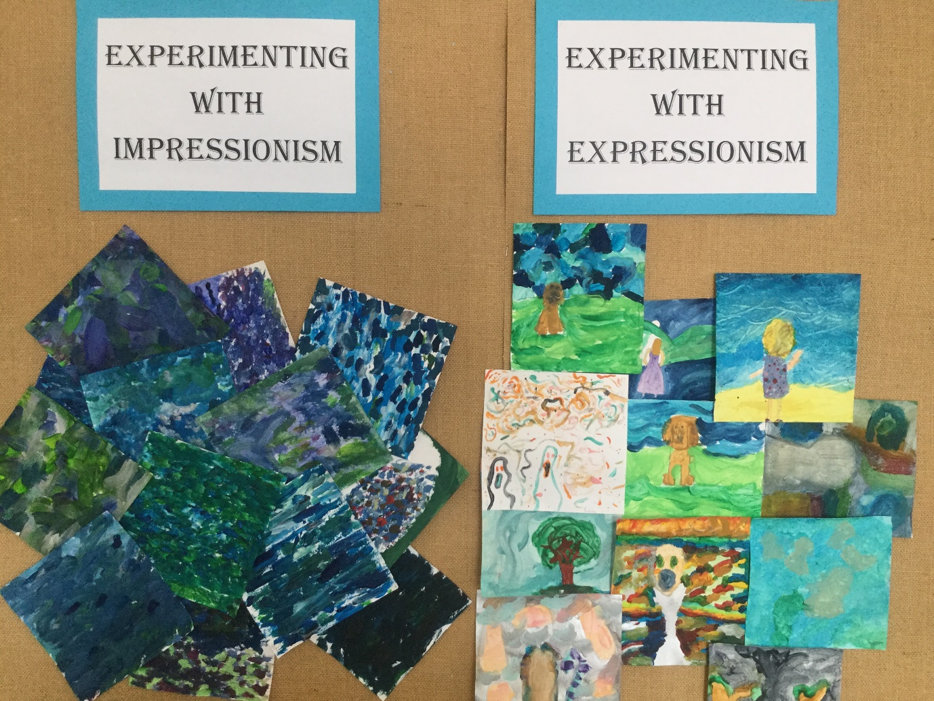

Thank you so very much for reading this blog its very cool of you, I will see you in the next blog we post here on the internet goodbye!

